The North Sea Advisory Council
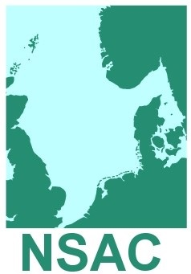
Executive Committee Meeting
Eggers Hotel
Drottningtorget 2-4
41103
Gothenburg
Sweden
Tuesday 6th March 2018, 10.30-15.30hrs

Agenda (2)
Agenda no.

- 10.30 Welcome and Introductions Niels Wichmann, Chair
Adoption of Agenda Niels Wichmann
Apologies Lorna Duguid

- 10.35 Report of last meeting 4th October 2017 Niels Wichmann
Adoption of Report (Paper 2.1 for Approval)
Actions Lorna Duguid

- 10.45 Scheveningen Group Update tbc

- 11.00 Update from European Commission tbc

- 11.15 Brexit Niels Wichmann
Report of Brexit Meeting (Paper 5.1 For Approval)

- 11.30 NSAC Meeting with DG Mare Niels Wichmann
Report of DG Mare Meeting (Paper 6.1 For Approval)

- 11.45 Demersal Working Group Update Barrie Deas
Draft Letter – Technical Con Regulation (Paper 7.1 For Approval)

- 12.30 Lunch

- 13.30 Ecosystem Working Group Update Euan Dunn

- 14.00 Skagerrak and Kattegat Working Group Update Kenn Skau Fischer
- 14.30 NSAC Advice Planner (Paper 11.1 for Info) Lorna Duguid

- 14.35 Reports from Meetings attended on behalf tbc
of NSAC; MIACO, EFCA Advisory Board, MAREFRAME

- 14.45 Preparing and Presenting NSAC Advice Niels Wichmann

- 15.00 Finance Update Lorna Duguid
2016-17 Year End Report (Paper 14.1 for Info)
2016-17 Audited Accounts (Paper 14.2 for Info)
2017-18 Budget Report (Paper 14.3 for Info)
NSAC EC Audit

- 15.10 Membership fees 2018/19 Niels Wichmann

- 15.20 Membership Lorna Duguid GA Application; FromNord (Paper 16.1 For Approval)

- 15.25 Date and location of next meeting
19th-20th June 2018, London

- 15.30 AOB and close of meeting

