The North Sea Advisory Council
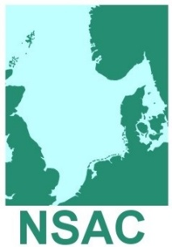
General Assembly 2018
Fishmongers’ Hall
London Bridge
London
EC4R 9EL

Wednesday 20th June 2018, 11.00hrs – 13.00hrs

Agenda No. Agenda (3)
1. 11.00 Welcome and Introductions Chairman, Guus Pastoor
Apologies Lorna Duguid
2. 11.05 Adoption of the Agenda Chairman
3. 11.10 Report of last GA meeting 14th June 2017 Chairman
Paper 3.1 Adoption of Report (For approval)
Actions from last meeting Lorna Duguid
4. 11.20 Opening Address to the General Assembly Nigel Gooding
Head of EU and International Fisheries, Defra
5. 11.50 EC and International Experiences of Governance Ernesto Penas Lado
and Advisory Structures
6. 12.20 Review of Year 2017-18 Lorna Duguid
Membership Update
Paper 6.1 NSAC Annual Report 2016-17 (For info)
Paper 6.2 NSAC Interim Report 2017-18 (For info)

7. 12.30 NSAC Accounts Lorna Duguid
Paper 7.1 2016-17 Audited Accounts (For info)
Paper 7.2 2017-18 Latest Finance Report (For info)
8. 12.35 NSAC 2018-19 Application for Funding Chairman
Paper 8.1 Work plan 2018-19 (For approval)
Paper 8.2 Budget 2018-19 (For approval)
9. 12.55 Date and location of General Assembly 2019 Chairman
Copenhagen, date to be agreed

10. 13.00 AOCB and close of meeting Chairman
Lunch will be served following the meeting

