North Sea Advisory Council
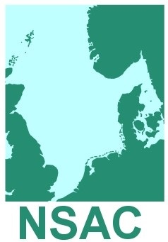

Paper No. 6.2 For Approval

Executive Committee
20th September 2018

NSAC Advice for Approval

This is paper is NOT approved NSAC advice.
Letter to Commission – Prohibited Species List

Dear Director General,
On October 4th, 2017 we wrote to you on the use of the prohibited species list and conditions that should apply to the listing of species on this article in the TAC & Quota regulation to prevent misuse of the list. We sent an update to this advice in January 2018 to which we received an oral response from the Commission.
We understand that looking towards the full implementation of the Landing Obligation the Commission has chosen to keep “all options open” and do not want to restrain the use of a possible flexibility measure. However, we further understand that you are willing to continue the discussion on how the list should be used in future after the full implementation of the Landing Obligation in 2019.
We therefore ask you to inform us if you plan on proposing a prohibited listing for species or stocks to December Council this year and we kindly request a meeting between yourself and delegates of the North Sea AC in early 2019 to discuss the future use of the list.

Yours sincerely,

Chairman NSAC

