North Sea Advisory Council
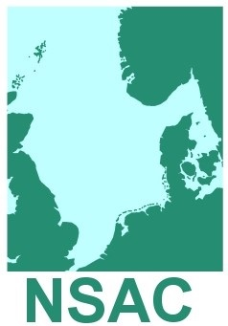

Paper No. 7.2 Paper for Discussion

Executive Committee
20th September 2018

NSAC Advice in Development

This is paper is NOT approved NSAC advice.
This paper has been drafted by the Skagerrak & Kattegat Working Group.

Version (2)

Removing the TAC for Whiting (Merlangius merlangus) in IIIa
(the Skagerrak and the Kattegat)

- Background Information
The salient fact:
- Whiting can be found all over the Skagerrak and Kattegat. However, currently there is no direct fishery, for the whiting. Whiting is mostly caught as bycatch in the demersal/Nephrops fisheries and the industrial fisheries. Improving selectivity may be possible in the future, but several projects have been conducted aiming at increasing the selectivity. This has in particular been the case in the demersal/Nephrops fisheries but so far without success as regards reducing catches or avoidance of whiting.
- Whiting in the Skagerrak and Kattegat is a jointly managed stock between EU and Norway. The TAC is agreed annually as part of the bilateral consultations between EU and Norway on the regulations on the fisheries in the Skagerrak and the Kattegat. There is no agreed management strategy for this stock.
- Since 2008 the TAC has been fixed at the level of 1.050 t - 19 t is allocated to Norway and 1.031 tons is allocated to the EU. Of the EU TAC 929 t is allocated to Denmark, 99 t to Sweden and 3 t to the Netherlands.
- Whiting in the Skagerrak and Kattegat is a low value stock with prices at auctions often less than 5 DKK per kilo (0,75 Euro per kilo). The demand is very low. This price level is not attractive as it does often not even cover the handling and landing costs. The value of landings of whiting in the Danish fisheries was in 2016 less than 750.000 DKK (> 100.000 Euro).
- There has not been a directed fishery for whiting in IIIa for a long time. Currently, the whiting is mainly caught as bycatch in the pelagic fishery for herring and sprat, and in the demersal trawl fishery for Nephrops. The stock has been covered by the landing obligation since January 2017.
- Recent annual catches (2012-2016) vary between 300 and 1,660 tonnes with an obvious increasing trend over the last five years. As there is no directed fishery for whiting in IIIa, the increasing catch can be seen as an indication of a positive growth in the stock. ICES estimate of discards for the years 2014-16 is 57%.
- The TAC is a so-called precautionary TAC. This follows from the fact that no reference points are defined and ICES does not perform an analytical assessment of this stock, mainly explained by the possibility of unknown stock mixing with neighbouring areas. The advice is based entirely on catch information. ICES framework for category 5 stocks is applied for the advice for this stock: scientific advice is given based on ICES’ internal precautionary rules, in casu as a recommended reduction of 20% on recently advised catch level.
- ICES will probably never be able to make an analytical assessment for this stock - given the size of the stock, scarce resources and common sense.
- Catches of whiting in scientific surveys (IBTS covering all IIIa and BITS covering only Kattegat) vary without an obvious trend, but with a tendency to increase in the later years.
- 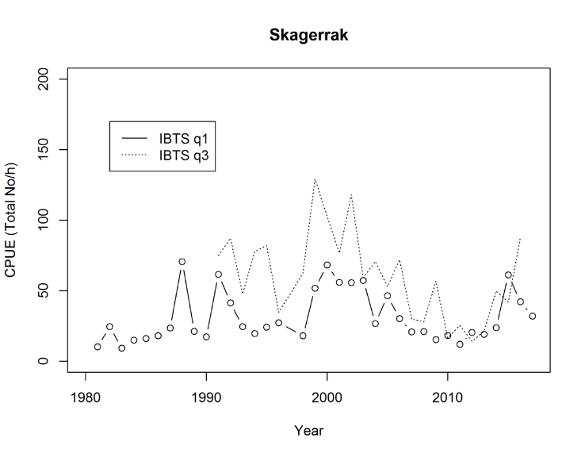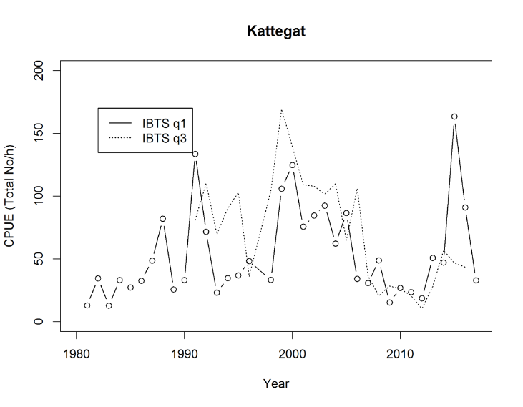
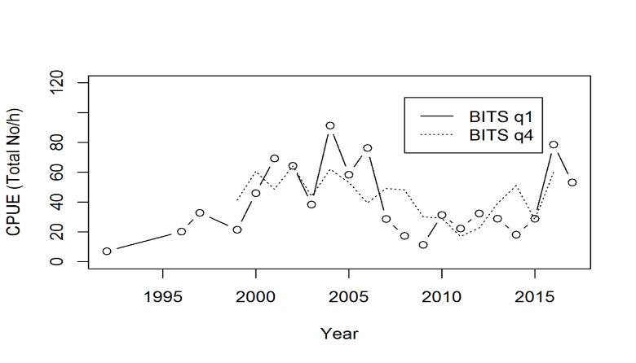
- NSAC Advice
2.1 The combination of the following factors is challenging for the fisheries in IIIa:
- The whiting stock cannot be expected to have an analytical assessment in the future,
- On the other hand, ICES’ principles will stipulate ongoing reductions in the TAC for the stock – no matter the actual trend in the stock,
- However, whiting is an unavoidable bycatch in the main fisheries, and this cannot be changed through selectivity and avoidance measures have limited scope because of the loss of target species
- Thus, with the landing obligation the whiting in IIIa will be a choke species.

  - The TAC for whiting in Skagerrak/Kattegat is a limiting factor for certain fisheries in the area and therefore other options of managing the stock within the basic principles of the CFP, i.e. ensuring the stock is managed within safe biological limits, need to be discussed.
  - The NSAC consider that removing the TAC for the whiting would be a progressive move that would be a helpful step in the full implementation of the landing obligation.
  - NSAC has published advice that set out the conditions that must be in place for the removal of a TAC to be accepted. It is obvious that a scientific assessment of the likely consequences of removing the TAC must be undertaken. ICES should be approached on this.
  - The stock must still be monitored and catches registered. ICES should assess the status of the stock at least biannually.
  - To prevent a targeted fishery for whiting, measures must be implemented. The composition of the catch may not exceed a certain percentage (this % needs to be evaluated and advised by ICES). The industry is not interested in jeopardising the process by allowing a changed regulation to become a way of counteracting the sensible measure of regulating without TAC. It is therefore imperative, that the landings of whiting are closely monitored and remedial actions in place before removing the TAC.
  - Further work to reduce bycatches of whiting in the fisheries should be initiated.

NSAC Advice 04-1718 TACs and Conditions for their removal

