North Sea Advisory Council
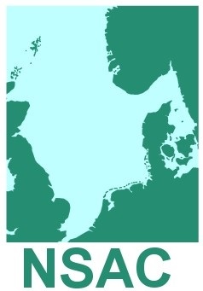

Landing Obligation Focus Group
Danish Fishermens’ PO
Axelborg,
Axeltorv 3, 1609
Copenhagen V

13.00 – 17.00hrs
22nd August 2018 Agenda (1)

- Welcome to members and apologies
- Adoption of agenda
- Update advice to prepare for Ex Com approval
Paper 3.1 Template (For Information)
- Agree schedule for Ex Com approval and submission of advice by 7th September
- Discuss and agree further work
- AOB

