October 9th, 2018

Dear members of the North Sea Advisory Council,

We herewith submit the application to select Zoetermeer (the Netherlands) as the new seat for the North Sea Advisory Council.
We have done our utmost to carefully elaborate our proposal and provide as much information as possible. In preparing this application, we have used the information provided to the Ex Com meeting of 20 September 2018 and translated this in the Dutch legal and administrative situation, as well as our own experience in establishing an organisation. The proposed stipulations are to be discussed and adjusted if deemed necessary. It is for NSAC ExCom and GA to take final decisions on draft texts, which are then to be transposed by a public notary into a legal deed.
In our proposal, we have aspired to keep the structure and practice of the destined NSAC close to the current situation. Regarding practices in organizing an Advisory Council in the Netherlands, we could reach out to the (well-functioning) Pelagic Advisory Council, as the PelAC is presently based in the Netherlands.
Regarding the interim phase; we will also respond to the invitation to tender for the interim secretariat. This solution would combine the interim secretariat with the transfer of the secretariat, allowing for a smooth transfer of operations and easily fulfilling the deadline of March 29th. However, the interim secretariat is not a condition for transfer, as the transfer could also take place while the interim secretariat is kept by another party.

We look forward discussing the proposal with you at the ExCom October 29th.

With best regards,
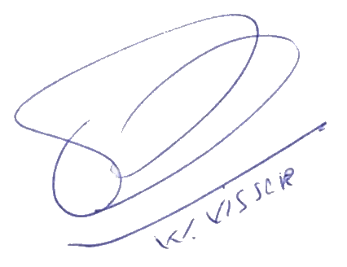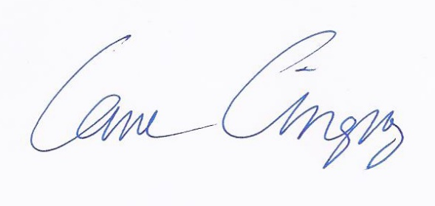
Pim Visser Irene Kingma
(chief executive VisNed) (director Dutch Elasmobranch Society)
Proposal to Host NSAC Secretariat

Member State | The Netherlands
Location | Zoetermeer
Establishing a company
Explain the process to establish a company within the proposed host Member State. Please include;
- Legal process. Estimate of costs for legal advice.
- Directors. Process to appoint Directors, do Director(s) have to be a resident in the host country (if yes then who is being proposed), minimum number of Directors required
- Time required to complete the process
- Cost to establish / register a company
We propose to make the NSAC an association with full legal capacity under Dutch law (vereniging met volledige rechtsbevoegdheid). This is one of the simplest legal entities in The Netherlands. In the following, we describe the main features of an association under Dutch law, how the NSAC would fit into the structure of such an association, and how to establish this association. Over all, the main objective is to maintain the current structure of the NSAC as far as possible.

Associations under Dutch law
The main characteristic of associations under Dutch law are:
- An association has members and each member is entitled one vote in the general assembly (GA).
- The general assembly has full power and authority. The association works through statutes that drawn up and approved by the GA and confirmed through a notary deed. At a minimum the statutes should specify:
  - Name of the organisation
  - Purpose
  - Obligation of its members
  - Rules governing the GA
  - Rules for appointing board members
  - Destination of surplus after dissolution
- Statutes can only be changed by the General Assembly, and any change requires a new notary deed.
- Next to the statutes such an association can have Rules of Procedure (huishoudelijk reglement) which set out the everyday operating of the association, the first set of Rules has to be set by the GA, but after that can be changed as agreed and changes do not require a notary deed.
- The GA appoints a board. It is common for an association to have at least three board members (chair, secretary, treasurer), but any other number is allowed as well. Board members have to be registered through the Chamber of Commerce and the process of adding or removing a board member is simple (can be done through an online form). Directors do not need to be local, or even EU residents. The board can appoint a Bureau (Dagelijks Bestuur).
- Board members are appointed by the GA, but upon establishment the directors are appointed by the founders. An association can be dissolved if the GA votes to do so, it no longer has any members, or it has been declared bankrupt. The rules and procedures for dissolving an association are included in its statutes.
- An association can employ staff directly. Members can be staff members too, but staff does not necessarily have to be member of the association. If staff is employed the fiscal rules for companies apply.
- There is no liability for office bearers (unless there is clear evidence of mal practice).
- Members of the board generally not be employees (consequently, board members are not covered under any employee insurance, but the association can have a general insurance for its board members).
- Members of the board can be reimbursed.
- Funders and subsidy providers often require that an association have 'full legal capacity' and that board members are not employees.

The NSAC as an association
As mentioned earlier, the association would mirror the current set up of the NSAC as much as possible. Our proposal:
- Organisations can become member of the association and each organisation can put one member forward for the GA.
- The general assembly (GA), meets at least once a year and approves the overall strategy, financial reports and budget of the NSAC. All members of the NSAC have a vote in the GA
- The GA choses a chairman, secretary and treasurer from their midst. All board members will be registered at the chamber of commerce.
- The Executive Committee functions as the board association, and is appointed by the GA.
- The Executive Committee is responsible for producing advice, sending representatives to meetings with relevant officials and fora and organising joint initiatives with other relevant stakeholders and/or scientists.
- The ExCom meets at least three times a year and from its midst choses the chairman of the Executive committee and two vice chairs. The vice chairs will be board members. The Executive committee chair functions as the director of the AC and is also head of the secretariat.
- The Exec chair as director does not have a vote in the GA and is not a board member, the role of the director will be defined through a separate director's statute.
- both in the GA and the ExCom will consist of 60% representatives of the fisheries sector and 40% other interest groups with each group responsible for the composition of its membership
- Working groups may be established to assist the ExCom at preparing advice. Both members of the GA and of the ExCom can participate in working groups.
- A secretariat will be established to do the daily work of the organisation, prepare and organize meetings and the financial administration. The secretariat (including the rapporteur) is appointed annually by the ExCom. The staff of the secretariat will not have a vote in the GA nor a seat in the ExCom. (A more detailed characterisation of the secretariat can be found later on in this document.)

Translated to an association under Dutch law, the structure could be drawn as follows:
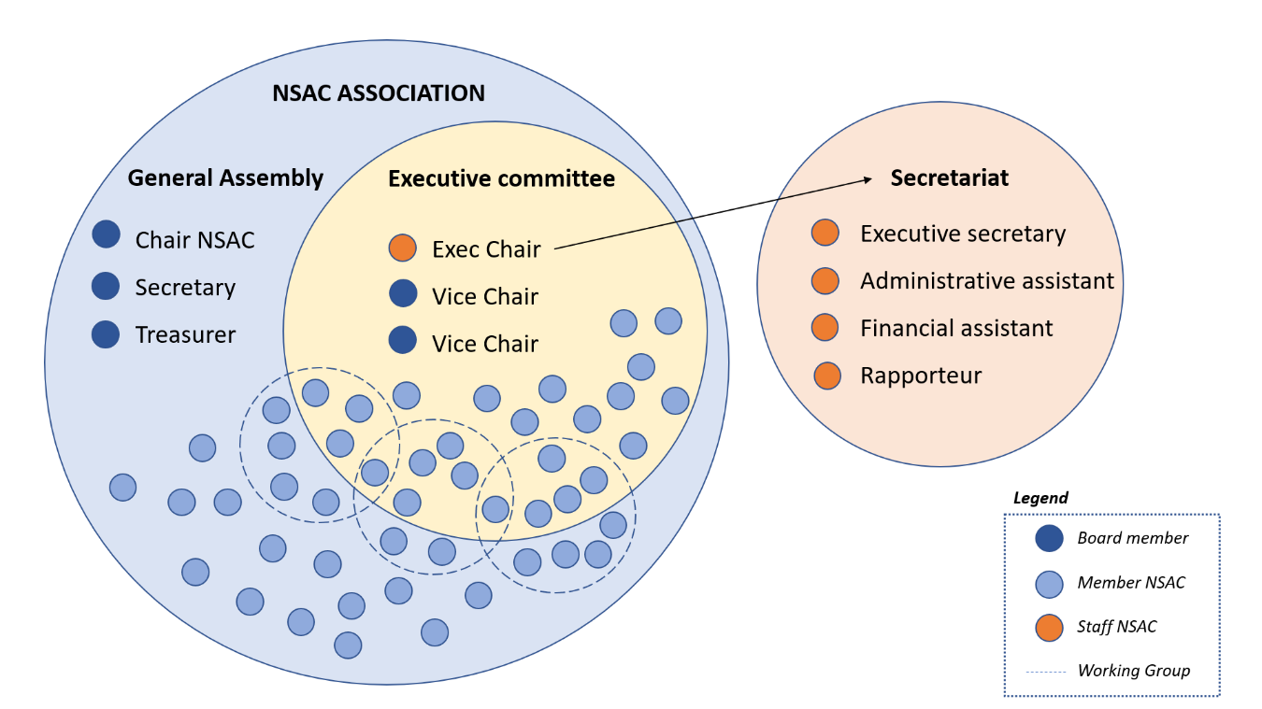

As stated earlier in this document, an association with ‘full legal capacity’ is set up via a civil law notary (notaris) who draws up a notarial deed of incorporation and also registers the business at the Dutch Chamber of Commerce (KvK). The notary needs the statutes of the association which include a name and address, purpose, member requirements, procedures for calling general meeting of members, rules for appointing and removing committee members and allocation of surplus after dissolution. Societies can also have rules of procedure (huishoudelijk regelement) in addition to their statutes. These detail the association's practical day-to-day affairs a notary act is not necessary to adopt or change the house rules.

Registration of an association at the Chamber of Commerce (KvK) can be done by any board member (in person). Upon registration, the Chamber of Commerce charges € 50,00. No further (annual) fees are due. The organisation then receives a KvK-number which is needed to open a bank account, receive funds and pay taxes.

The second step would be to have a civil notary set up a notary deed (based on the statutes) this can be done within a day. The processing by the Chamber of Commerce takes a few (2 - 3) business days maximum. The total costs for the civil law notary to write and register the deed are approx. € 1,000. Further legal advice (and fees) would only be required if the association would have special wishes with regard to e.g. its governance, employment structure or insurance.

After establishment of the association and the registration at the Chamber of Commerce, the transfer agreement can be signed to legally finalize the transfer of the NSAC to the Netherlands. The association will be set up in accordance to Article 43-45 and Annex III of the Common Fisheries Policy and delegated act 2017/1575.

Establishing a Bank Account
Explain the process required to establishing a bank account.
Is a resident in the host country required, if yes who is proposed
Time required to set up a bank account
Costs / minimum deposit
The proposed bank is the Rabobank. This is one of the major banks in the Netherlands. Rabobank is an international financial services provider. It offers retail banking, wholesale banking, private banking, leasing and real estate services. As a cooperative bank, Rabobank puts customers’ interests first in its services. It serves approximately 8.4 million clients around the world. Their strong agricultural roots mean that they have unparalleled knowledge in the food and agri industry. Their ambition is to become the world’s leading food and agri bank.

Establishing a bank account is quite simple. The only real requirement is for the organisation to have a registration number from the Dutch Chamber of Commerce (KvK). As said before, this is a quick and simple process. Dutch law obliges for Rabobank to establish the identity of the person opening the account as they will be the named person with access to the account. Therefore, it is mandatory, for establishing a bank account, to prove one’s identity in person at one of Rabobank’s many offices in the Netherlands. This person does not need to have the Dutch nationality. The establishing of a bank account can be fixed within a maximum of 5 working days.

We propose that the board member taking on the role of treasurer will establish the bank account on behalf of the NSAC. Once the account has been established other individuals can be given access to the account.

The costs of a bank account by the Rabobank will be € 5,30 per month. This include a Rabo Scanner (device to access your online bank account and to process your transactions), digital statement of account and an app to manage your bank account on your phone. The Rabobank reimburses the costs of transactions up to a maximum of € 25, - per month. Depreciation, more than € 25, - per month, costs € 0,08 per transaction. Credits, more than € 25, - per month, costs € 0,15 per transaction. It is also possible to get a credit card (VISA or Mastercard) linked to the Rabobank account.

Proposed Office Location
Details of office location
Terms of rental / lease, length of agreement, period of notice required to leave
Date when office is available
What is included within lease agreement e.g. rates, taxes, telephones, Wi-Fi, insurance, heating cleaning, other services.
Connectivity of the Netherlands
The Netherlands is a thriving, independent, prosperous and internationally oriented country in the heart of Europe. The Netherlands has long been situated at Europe’s trading crossroads and is one of the founding nations of the European Union. The country’s international orientation provides a gateway into Europe that helps international organisations and companies succeed throughout the continent. Situated between the three largest economies in Europe (Germany, the United Kingdom and France), the Netherlands offers an attractive, stable and highly accessible location of the NSAC.

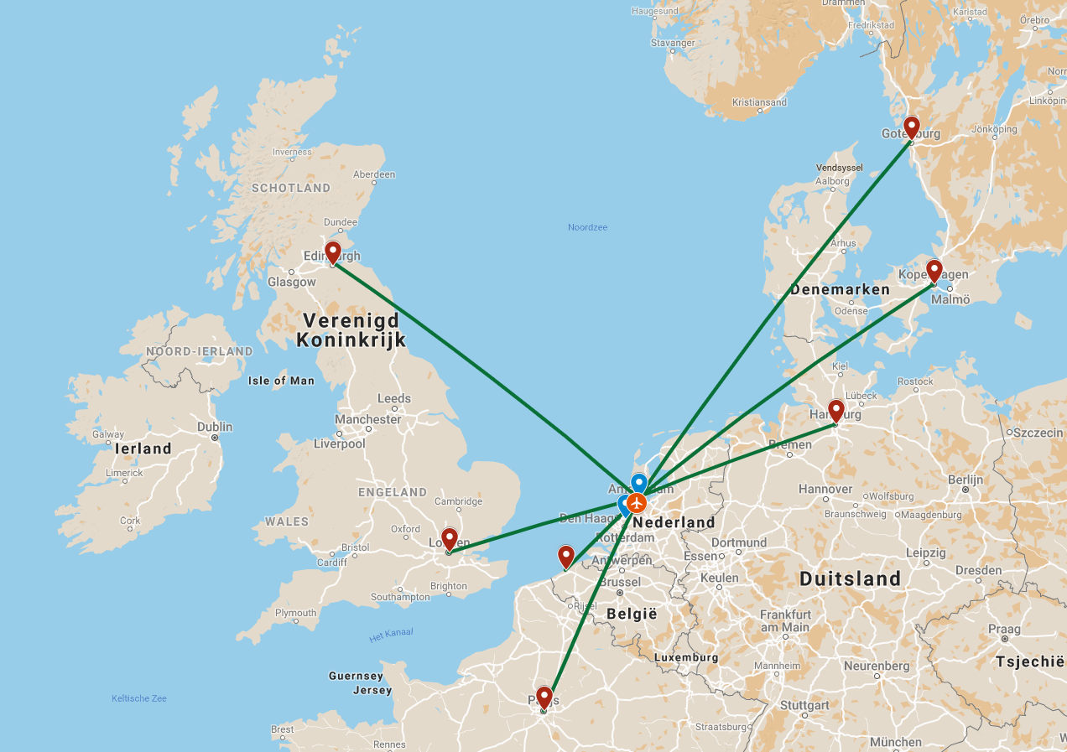
In relocating to the Netherlands, the NSAC will be able to run its operations from a strategic location on the European mainland that offers unparalleled EU and international access. This is a result of our country’s favourable, central geographical position, its superb accessibility and excellent infrastructure. The proposed location for the NSAC office is located near an international airport hub offering high frequency, direct flight connections to capitals and other destinations in all EU Member States as well as a variety of routes to its main international counterparts across the globe.

Amsterdam Airport Schiphol
Amsterdam Airport Schiphol is the third-largest airport in the EU, with over 63 million passengers a year and serving 322 non-stop destinations in 95 countries. Amsterdam Airport Schiphol has daily connections to all EU Capitals and many international destinations, including in the USA and Asia. With 4.861 direct flight connections per week, it has the highest number of direct flight connections in comparison with other airports in Europe. It is one of the most efficient single terminal airports in the world. The ground connections to-and-from Amsterdam Airport Schiphol are excellent. The airport is connected to one of the most high frequency domestic rail networks in Europe and has direct High-Speed rail connections to Brussels, Paris, Frankfurt, and London.

Furthermore, several airports with European and International flight connections can also be reached within one to two hours travelling time, including Rotterdam-The Hague Airport and Brussels-Zaventem Airport respectively.

Road and rail connectivity
The Netherlands has an extensive road network and high frequency rail network. By car, every destination within the Netherlands can be reached in less than 2.5 hours. Amsterdam Airport Schiphol is connected to major motorways: A2/E35 and A4. The rail network operating from Amsterdam Airport Schiphol has high frequency services (8-12 connections per hour). High Speed services are available from cities in nearby countries such as Belgium, France, Germany and the UK (Thalys, ICE).

Indication of travel time, options and costs

 | Time | Options | Costs
Gothenburg | 90 min to fly | 5-6 flights per day | €200 per flight
Copenhagen | 75 min to fly | 10-14 flights per day | €150 per flight
Hamburg | 60 min to fly | 5-7 flights per day | € 175 per flight
Paris | 3,5 hour by train | every hour | €50
Ostend | 3 hour drive | every moment
London | 60 min to fly | 50 flights per day | €75 per flight
Edinburgh | 90 min to fly | 6-8 flights per day | €150 per flight

Proposed Office Location
We propose the NSAC joins the fisheries cluster that is already located in Zoetermeer, where the Pelagic Freezer-trawler Association (PFA), the Visfederatie (national organisation of processors and traders of fish), VisNed and the secretariat of the Pelagic Advisory Council share office space at the seventh floor of the Zoetermeer Central Station business centre. Zoetermeer is surrounded by infrastructure: positioned next to the A-12 (a main connecting highway) and it is only a few minutes walk to the train station.

On the structure of the fisheries cluster: The PFA has a rental agreement with the landlord, which is extended on a yearly basis. The other organisations are subtenants of the PFA. The agreements include:
- service (front desk including receptionist, use of a meeting room up to 15 pers.)
- cleaning (on a daily basis)
- subsidized canteen at the ground floor
- fiber optic connections for internet

The space the NSAC would be using is about 25 m2 and has a capacity for placing two to three desks. The room is available from the first of December 2018. The room has a wide view and on bright days one can even see the harbour of Rotterdam and the skyline of The Hague about 10 km away!

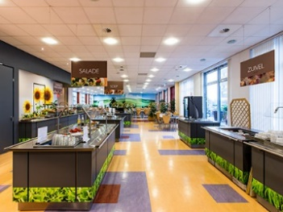
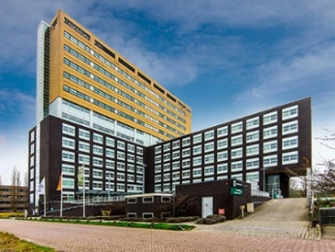
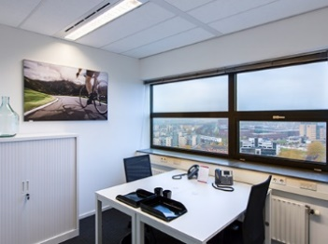
Proposed Standard Meeting Locations
There are several options for meeting spaces in the direct vicinity of Schiphol airport. An advantage here is the number of NSAC member organisations which have offices in The Netherlands. The North Sea Foundation is based in Utrecht next to the Central Station and has a meeting room of up to 15 participants. The Dutch Elasmobranch Society has a meeting facility in the centre of Amsterdam for up to 8 participants.

We propose the Amsterdam Art Center to become a regular meeting location for larger meetings (General Assembly, Demerals Working Group and/or the Executive Committee). The Art Centre is located in Amsterdam and easily accessible, both by car (next to the highway and including free parking space) and by train (a direct connection takes you from station Sloterdijk to Schiphol Airport in 10 minutes). The Art Centre combines artwork rental and meeting rooms in one location, which creates an inspiring atmosphere as visitors can explore the amazing repository of artworks during their coffee break!

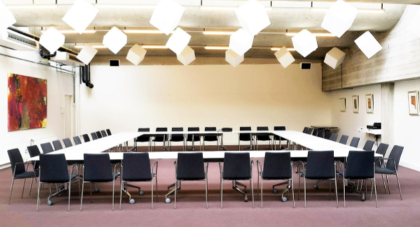Another option for larger meetings is the Park Hotel in The Hague, this has been the preferred location for PelAC meetings in the past years. The clear advantage of this location is that they offer a low rate on rooms for meeting attendees (€130 incl. breakfast) and the venue has a very high service level (good wifi, good food, translation booths available).
For smaller ad hoc groups, a meeting room at Schiphol Airport may also be an option, which allows members to easily travel back and forth on the same day.

Tax Regime
Explain any taxes the NSAC would be liable to pay and current tax rates
The NSAC association will be automatically registered with the Tax and Customs Administration when it is listed it in the Dutch Commercial Register (Handelsregister) at the Netherlands Chamber of Commerce (KvK). The Belastingdienst (Dutch tax office) collects taxes through a variety of streams.

Payroll tax (loonheffing)
Payroll tax is tax and other contributions that are withheld from an employee’s salary by the employer, which saves the employee from having to pay them later as income tax. The payroll tax levy is made up of tax on your salary (wage tax or loonbelasting) and national insurance contributions for pensions, unemployment allowance and other Dutch benefits and allowances.

VAT sales tax (BTW / omzetbelasting)
The Belastingdienst also collects taxes via the sales or revenue tax (omzetbelasting), known in the Netherlands as BTW (belasting over de toegevoegde waarde). All businesses, foundations and associations, must add BTW to the price of their goods and services. There are three different levels of BTW: 0%, 6% and 21% (the most common rate). The new association will not be VAT exempt and will need to add 21% to its grant application to the Commission and any other funds it applies for. The association will need to make a VAT statement at the end of every quarter of a year and pay the total of VAT required for that quarter directly. Most VAT on sales invoices payed by the AC can be deducted from the VAT statement of a given quarter.

Profit TAX (Winstbelasting)
The AC is a not for profit organisation and aims to spend all of the funds received in a given year and will therefore not be subject to profit TAX in The Netherlands.

Audit
Explain the audit processes required of a company within the proposed host country. Estimate of annual costs for audit
The proces of auditing won’t differ much from the current process. As the rest of this tender, we've tried to stay as close as possible to the currect pratice of the NSAC. Company law requires the directors of associations to prepare financial statements for each financial year.
Directors must not approve the financial statements unless they are satified that they give a true and fair view of the state of affairs, the surplus or deficit of the association. The objective of a audit is to obtain reasonable assurance about whether the financial statements as a whole are free from material misstatement, caused by to fraud or error.

To estimate the costs of a audit, it is important to notice that it is permitted to tender this. The first year of a audit is the most expensive, so it is recommendable te tender it for more than one year. The audit will be done by an extern and proffesional company wich is specialized in auditing companies and associations. It is recommendable to choose a auditor with some knowledge of fisheries and maritime subjects. Our estimation of the costs of a audit process for one year will be 12.500 euro.

Staffing
What is the proposal for providing staff for the secretariat including
Structure of the secretariat; roles and numbers
Employment status; contract, employed, secondment
Legal obligations of employment status (if appropriate)
Executive secretary is the primary employee of the AC, his or her tasks include:
- Responsible for planning an execution of AC meetings
- Coordinates AC advice
- Main point of contacts for AC to AC, MS, AC members and others
- Responsible for grant renewal to EC
- Responsible for year plan & reporting to EC
- Composes the monthly members newsletters and quarterly stakeholder updates

Administrative assistant supports the Executive secretary in the back office tasks of the secretariat:
- Checks and pays reimbursement claims
- Preparations for AC meetings (send documents, book venues etc)
- Maintains a register of members
- Ensures mailing lists are up to date and mailings get send timelye
- Manages and updates the NSAC website

Financial assistant supports the secretariat in the book keeping of the AC
- Ensures the quarterly TAX statement is correct
- Prepares and check the annual statement for the auditors

Rapporteur
- Takes notes and writes the report on ExCom, GA and Working group meetings
- Has an active drafting role in the advice drafting process in focus groups where necessary

The organisational form of the NSAC as an association both allows for tender for services and direct employment. Under Dutch Law, when labour contracts are offered through a fixed term contract, only under specific circumstances an extra months salary will have to be paid upon termination. After three years of temporary employment, a contract for an indefinite period needs to be offered to continue employment. Termination then will then require a court ruling, which will be granted if there is a valid reason for termination. If the employer follows the straightforward instructions on this matter, the financial risks and obligations are minimal. We can use the human resource arrangements the of PelAC in this respect.

If work is to be tendered to either a company or a free-lance professional this requires a simple agreement on assignment (overeenkomst van opdracht), stipulating that both parties agree that the work is not carried out in the form of an employee-employer form but pertains to a particular assignment the consultant will carry out. This can be easily done for the rapporteur or financial assistants' duties, as those are clearly defined, but are less so for the executive secretary and administrative assistant as they will fall direclty under the Executive chair. For this reason, we propose to employ the staff for the post of executive secretary and the administrative assistant, starting with a fixed-term contract of one year. The financial assistant on the other hand can be sub contracted without a problem.

IT Systems
Explain the systems that will be set in place for communications.
Hosting NSAC website and email systems.
IT support systems and costs
General administration
We propose to use Microsoft Office 365 as our main administrative package, as this is the most widely used system and aligns with the systems used by the PelAC.

Financial administration
Together with the financial assistant an online book keeping program will be chosen which allows clear insight in the financial process of the AC for all those who need access (secretariat, treasurer, auditor & financial assistant). This will also allow to add a ‘four eyes’ principle to AC finances which is needed for EC funding and audit. An example of an online bookkeeping programme suitable for the Dutch market is Moneybird (www.moneybird.nl)

Webhosting and website support
For hosting the NSAC website we propose to use the same host as the Pelagic AC is using: Wipesoft (https://www.wipesoft.nl/webdesign). We will tender out the webhosting and support on an annual basis.

Contributions
Please state contributions offered, cash or in-kind from Member State or other third party
As mentioned earlier, the office space will be shared with other fisheries organisations that operate on an international level: Pelagic Freezer-trawler Association (PFA), the Visfederatie (national organisation of processors and traders of fish), VisNed and the secretariat of the Pelagic Adivisory Council. This his can be a major benefit of hosting the secretariat of the NSAC in the Netherlands.

There are 4 NSAC member organisations based in The Netherlands (from industry and OIG side) this allows for close cooperation and work sharing between organisations. We already mentioned this under the meeting locations section, but this will also help in other support needs of the secretariat.
The Dutch government in supportive of our application. Minister Carola Schouten will issue a letter in that respect, which will be sent to you in a later stage. The in kind contributions by the Dutch Government shall comprise of making available meeting facitilites in their Ministry of Argiculture, Nature and Foodsecurity. As a Dutch organisation, NSAC cold also apply for EMFF funding if projects were to be initiated

Implementation
Who will be the named person responsible for coordinating and implementing the transfer process.
What resources / time do they have available to commit to the transfer.
Timeline for implementation, identifying key milestones and date relocation will be completed
The NSAC has put a tender out to find a temporary replacement for when Lorna Duguid leaves and until the secretariat can move to a new location (March 2019). During this period, we will work closely with the interim secretariat on organising a smooth transition.

We propose to set up a transitional support group consisting of:
- NSAC ExCom chair
- Pim Visser (VisNed)
- Irene Kingma (Dutch Elasmobranch Society)
- Noor Visser (VisNed)
To take the lead in preparing all needed documentation and processes.

As soon as there is agreement on the transition to the Netherlands we can start the application process to find suitable candidates for the secretariat positions which shall be installed no later than the 30th of March 2019. By this time the secretariat of the AC will be an independent functioning body.

During the interim period, Noor Visser (VisNed staff) will be full time available to guide the transfer process and carry out the tasks of the secretariat during this period. Other members of the VisNed staff can support her if needed.
During November, she could travel to Aberdeen to take over the ongoing work of the current secretariat. VisNed will be tendering for the interim secretariat, although transition of the NSAC to the Netherlands can also be completed without the interim secretariat.

Other Information
Please add any other relevant information

