North Sea Advisory Council
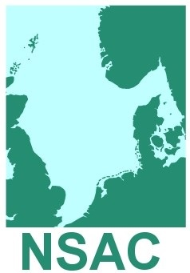
NSAC Control Focus Group
Danish Fishermen PO
Rue du Luxembourg 47-51
1050 Bruxelles

16th January 2019 11.00-15.30 hrs Agenda (1)

- Welcome, Introductions and Apologies Chairman

- State of Play

- Discussion of draft document
- Small-scale fisheries
- Enforcement and sanctions
- Use of new technology including CCTV
- Marking of fishing gear
- Control of fishing opportunities
- Weighing, transport, sales
- Engine power

- Next steps, NSAC Forwards Process
- Close of Meeting

