The North Sea Advisory Council
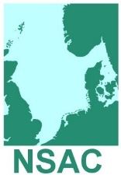
Focus Group
Terms of Reference
Choke Risk

Purpose (aims and objectives):
- To identify potential Choke Risks in the North Sea Demersal Fisheries
- To identify possible mitigation measures
- To prepare draft advice that takes into account:
- Avoidance and selectivity options
- Legal constraints
- International Fisheries Negotiations, including long-term management strategies
- Inter-species interactions and shifting population distributions
- Balancing rebuilding strategies and short-term socio-economic consequences
- To take into account unintended (but not necessarily unforeseeable) consequences of management measures
Recipients of Advice (target audience):
The Commission, PECH Committee, Scheveningen Group
End result (main headings):
- Avoidance and selectivity options
- Legal constraints
- International Fisheries Negotiations, including long-term management strategies
- Inter-species interactions and shifting population distributions
- Balancing rebuilding strategies and short-term socio-economic consequences
Measures of success (Key Performance Indicators):

